
Our Clinical Cases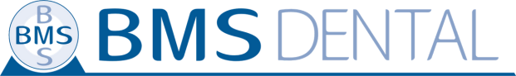
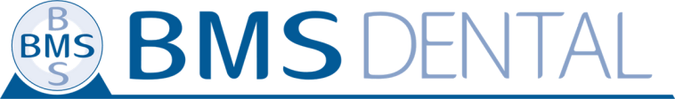
BMS White 38%
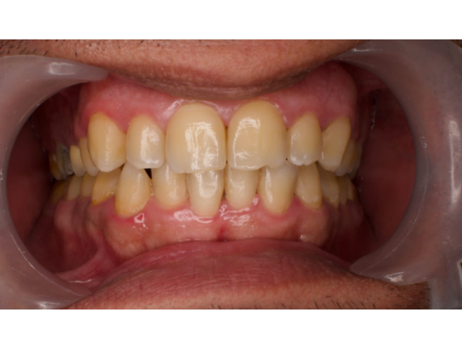
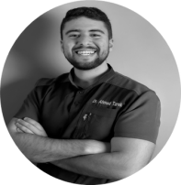
Dr. Ahmed Tarek Abdullah 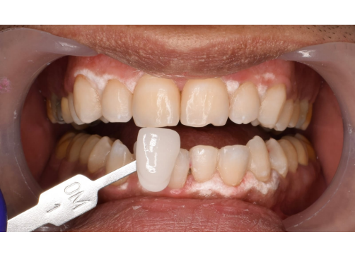
BMS White
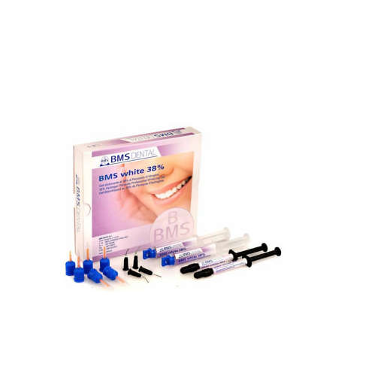
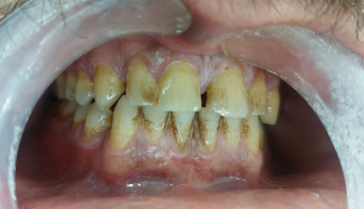
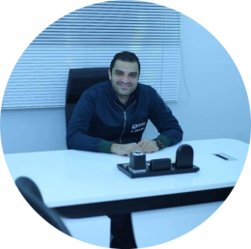
Dr. Ahmed Niazy
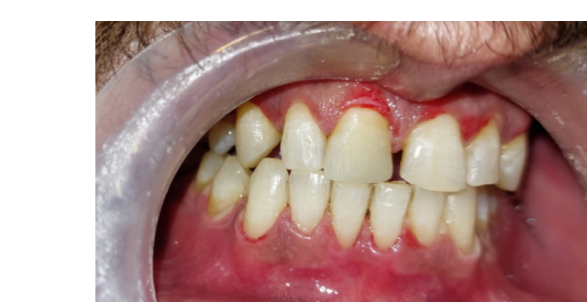BMS White
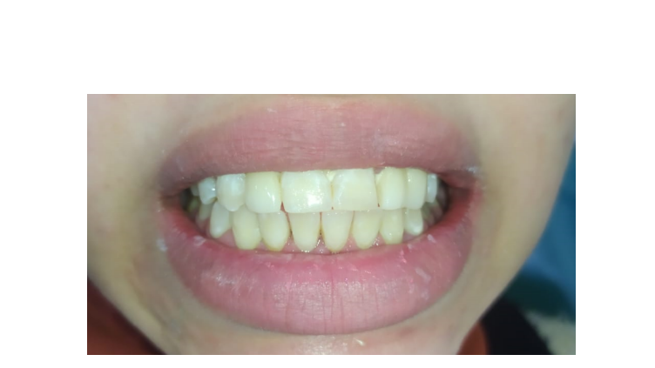
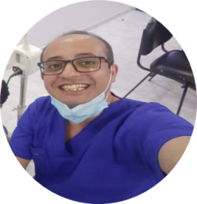
Dr. Arsany Bassium
BMS White
Dr.Ahmed Abosalem
BMS White
Dr.Ali Farah
BMS White
Dr.KareemEl Serafy
BMS White
Dr Marwa shaker
BMS White
Dr.Mohamed Men'em
BMS White
Dr. Basil Mumtaz
Dr. Amr Baghagho
Dr. Amr Baghagho
Dr. Ahmed Salah Sahaly
Dr. Ahmed Salah Sahaly
Dr. Ali Eldeak

